TOPIC 5.7 : HUFFMAN CODING
Problem Statement
Given a set of characters and their corresponding frequencies, construct the Huffman Tree and generate the Huffman Codes for each character.
Test Case 1
Input:
n = 4
characters = ['a', 'b', 'c', 'd']
frequencies = [5, 9, 12, 13]
Output: [('a', '110'), ('b', '10'), ('c', '0'), ('d', '111')]
Test Case 2
Input:
n = 6
characters = ['f', 'e', 'd', 'c', 'b', 'a']
frequencies = [5, 9, 12, 13, 16, 45]
Output: [('a', '0'), ('b', '101'), ('c', '100'), ('d', '111'), ('e', '1101'), ('f', '1100')]
Aim
To write a program that constructs the Huffman Tree from given characters and frequencies, and generates Huffman Codes for each character.
Algorithm
- Start
- Create a priority queue with nodes as (frequency, character)
- While more than one node remains:
  - Extract two nodes with smallest frequencies
  - Create a new internal node with these two as children and frequency equal to their sum
  - Insert the new node into the queue
- The remaining node is the root of the Huffman Tree
- Traverse the tree to assign binary codes: left edge → 0, right edge → 1
- Store and return codes for each character
- Stop
Input and Output
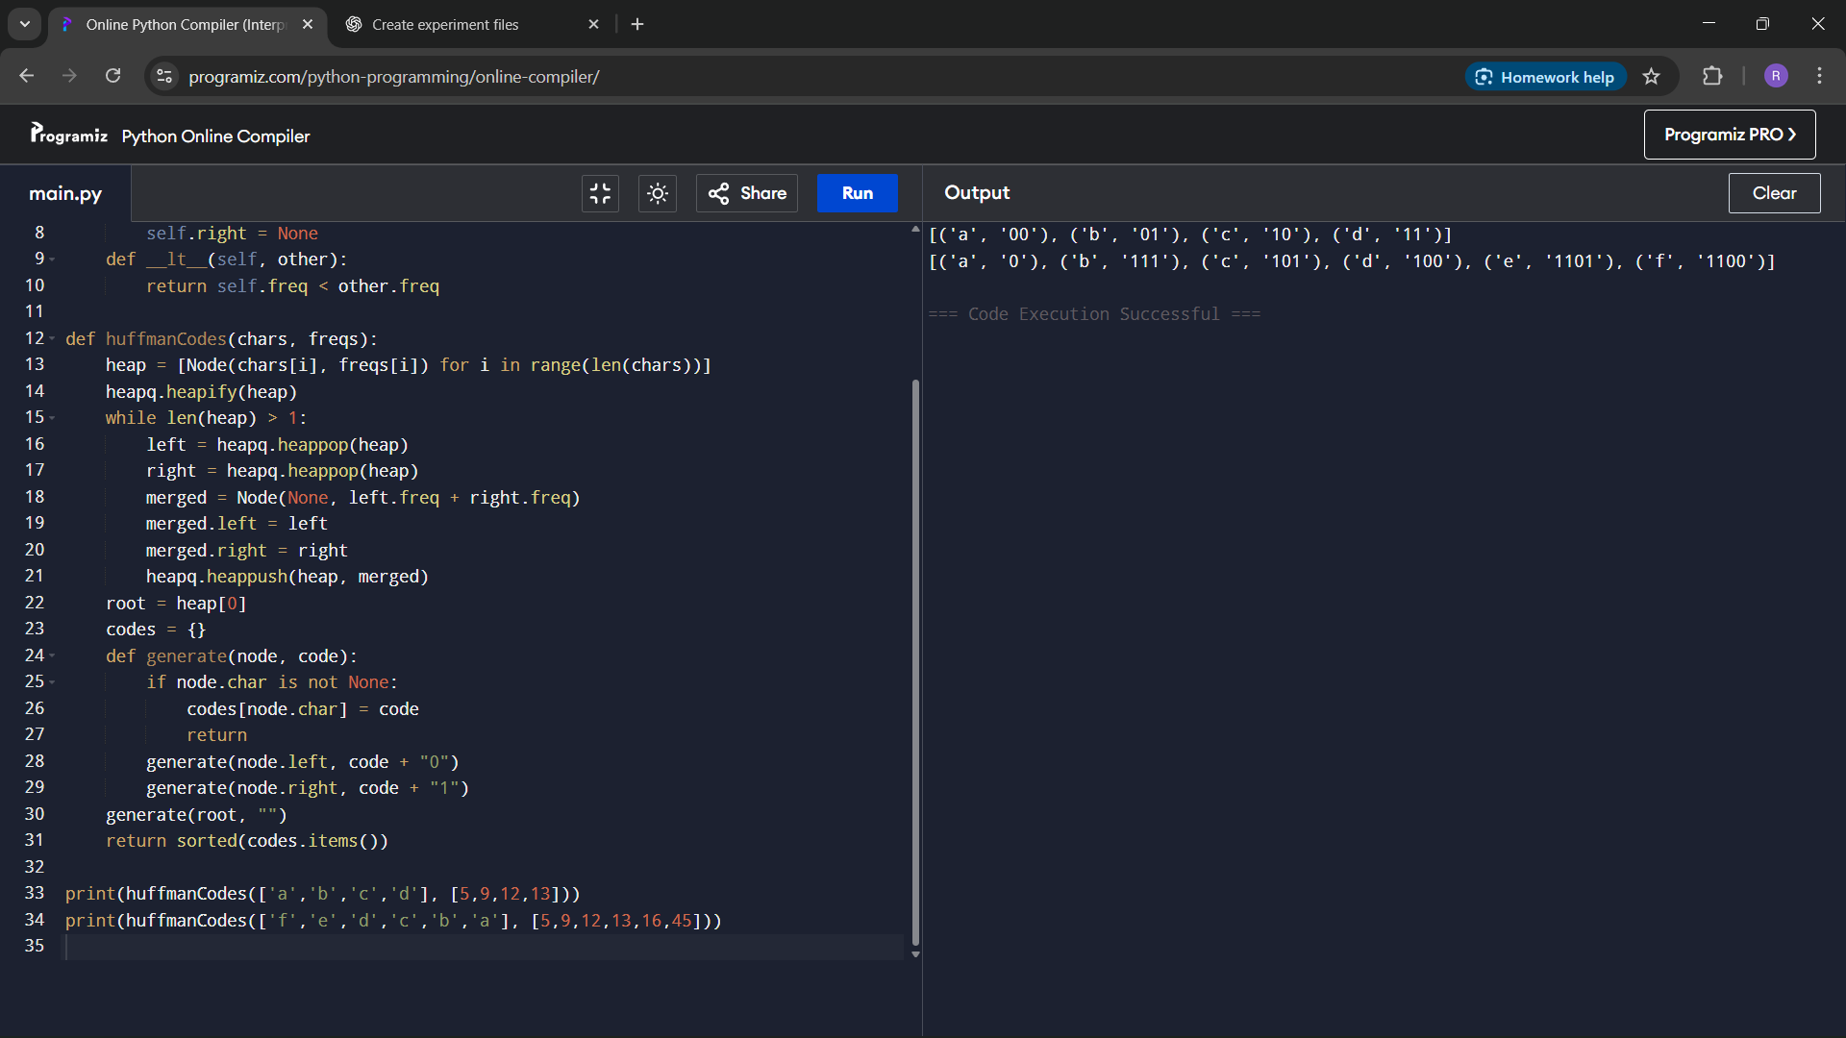

Result
The program successfully constructs the Huffman Tree and generates Huffman Codes for the given characters.
Performance Analysis
Time Complexity: O(n log n) due to priority queue operations
Space Complexity: O(n) for storing nodes and codes

